HTTP
Advanced Topics
Compression · Persistent Connections & Keep-Alive · Multipart & Chunked Transfer
Concept, full Express.js implementation, and interview questions — per section.
01 — Compression | 02 — Keep-Alive | 03 — Multipart & Chunked

01 | HTTP Compression  How servers shrink response bodies before sending them — and why it matters more than you think

What It Is and Why It Exists
Every byte that travels between your server and client costs time and money — network latency, data transfer fees, and slow page loads. HTTP compression solves this by having the server squeeze the response body down before sending it, and having the client decompress it on arrival. The whole process is transparent to your application code — you write JSON, the middleware compresses it, the browser decompresses it, and your JavaScript sees plain JSON.
The negotiation works like this: the client sends Accept-Encoding: gzip, br, deflate in the request, telling the server what algorithms it can handle. The server picks the best one it supports, compresses the body, and tells the client which algorithm it used via Content-Encoding: br. The client decompresses accordingly. Neither side has to agree beforehand beyond this header exchange.
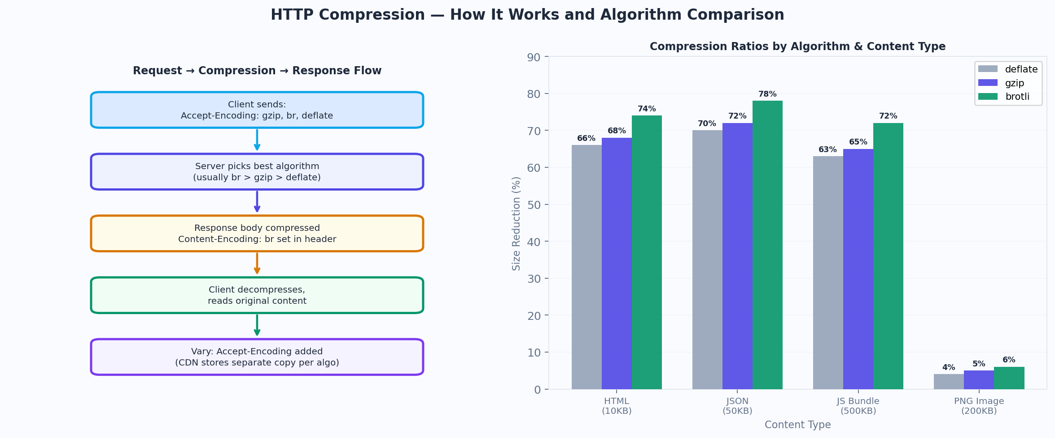
Figure 1 — Compression negotiation flow and algorithm comparison by content type

The Three Algorithms
You will encounter three compression algorithms in HTTP:
- Gzip — the universal default. Supported by every client and server since 1992. Uses the DEFLATE algorithm with a gzip wrapper. ~65-75% size reduction on text.
- Brotli (br) — Google's algorithm, introduced in 2015. Consistently 15-20% better than gzip on the same content. Supported by all modern browsers. Requires HTTPS in browsers (a practical constraint). Your server should prefer this when the client advertises support.
- Deflate — the raw DEFLATE algorithm without gzip's header. Rarely used directly because implementations varied and gzip compatibility was universally better. You can mostly ignore deflate in modern systems.

Important: compression only helps for compressible content — text-based responses like JSON, HTML, CSS, JavaScript, and XML. For already-compressed formats like JPEG images, PNG files, MP4 videos, and ZIP archives, HTTP compression adds CPU cost with near-zero size benefit. Most compression middleware is smart enough to skip these types automatically.
Why this matters
Without compression, a 500KB JSON API response travels as 500KB over the wire. With Brotli, the same response might be 140KB. That's a 72% reduction. For mobile users on 4G, this is the difference between a 2-second and 0.5-second API call. Multiply by thousands of requests per day.

Full Express Implementation
The compression package handles everything automatically. It reads the client's Accept-Encoding header, compresses eligible responses, and sets Content-Encoding and Vary: Accept-Encoding for you. When you need fine-grained control — like streaming compressed data or compressing specific routes only — you go lower-level.
install
npm install compression

compression/app.js — full working implementation
const express = require('express')
const compression = require('compression')
const zlib = require('zlib')
const path = require('path')
const fs = require('fs')
const app = express()

━━━━━━━━━━━━━━━━━━━━━━━━━━━━━━━━━━━━━━━━━━━━━━━━━━━━━━━━━━━━━━━━━
STRATEGY 1 — Global middleware (covers 90% of use cases)
━━━━━━━━━━━━━━━━━━━━━━━━━━━━━━━━━━━━━━━━━━━━━━━━━━━━━━━━━━━━━━━━━
app.use(compression({
level: zlib.Z_BEST_SPEED, // level 1 (fastest) to 9 (best ratio). 6 is default.
threshold: 1024, // skip compression if body < 1KB (not worth it)
// filter: which responses to compress
// By default compression skips: images, videos, audio, zip, pdf
filter: (req, res) => {
// Opt out: client can send Cache-Control: no-transform
if (req.headers['cache-control'] === 'no-transform') return false
// Fall back to compression package defaults for everything else
return compression.filter(req, res)
}
}))

━━━━━━━━━━━━━━━━━━━━━━━━━━━━━━━━━━━━━━━━━━━━━━━━━━━━━━━━━━━━━━━━━
STRATEGY 2 — Per-route: heavy payload that especially benefits
━━━━━━━━━━━━━━━━━━━━━━━━━━━━━━━━━━━━━━━━━━━━━━━━━━━━━━━━━━━━━━━━━
app.get('/api/report', async (req, res) => {
const report = await generateLargeReport()

// res.json() triggers the global compression middleware automatically
// You do nothing extra. The pipeline: your JSON → gzip/br → client
res
.set('Cache-Control', 'public, max-age=300')
.json(report)
})

━━━━━━━━━━━━━━━━━━━━━━━━━━━━━━━━━━━━━━━━━━━━━━━━━━━━━━━━━━━━━━━━━
STRATEGY 3 — Manual zlib: compress a file and stream it yourself
━━━━━━━━━━━━━━━━━━━━━━━━━━━━━━━━━━━━━━━━━━━━━━━━━━━━━━━━━━━━━━━━━
app.get('/download/data.json', (req, res) => {
const acceptsGzip = req.headers['accept-encoding']?.includes('gzip')
const acceptsBrotli = req.headers['accept-encoding']?.includes('br')
const fileStream = fs.createReadStream(path.join(__dirname, 'data/large.json')

if (acceptsBrotli) { // brotli preferred: better ratio
res.set({'Content-Encoding': 'br', 'Content-Type': 'application/json' })
fileStream.pipe(zlib.createBrotliCompress()).pipe(res)
} else if (acceptsGzip) { // fallback to gzip
res.set({'Content-Encoding': 'gzip', 'Content-Type': 'application/json' })
fileStream.pipe(zlib.createGzip().pipe(res)
} else { // no compression supported
res.set('Content-Type', 'application/json')
fileStream.pipe(res)
}
})

━━━━━━━━━━━━━━━━━━━━━━━━━━━━━━━━━━━━━━━━━━━━━━━━━━━━━━━━━━━━━━━━━
STRATEGY 4 — Disable compression for a specific route
━━━━━━━━━━━━━━━━━━━━━━━━━━━━━━━━━━━━━━━━━━━━━━━━━━━━━━━━━━━━━━━━━
app.get('/api/images/:id', (req, res) => {
// Images are already compressed — forcing gzip wastes CPU
// Tell compression middleware to skip this response
res.set('Cache-Control', 'no-transform')
res.sendFile(path.join(__dirname, `uploads/${req.params.id`)
})

app.listen(3000)

Watch out
Never compress already-compressed formats (JPEG, PNG, MP4, ZIP, PDF). The result is often larger than the original because compression algorithms add overhead. The compression middleware skips these automatically by MIME type, but if you are doing manual piping with zlib, you must check the content type yourself before deciding to compress.

Checking Compression is Working
In Chrome DevTools → Network tab, select any API request. In the Headers section, look for Content-Encoding: gzip or Content-Encoding: br in the response headers. In the Size column you will see two numbers — the compressed size (what traveled over the network) and the uncompressed size (what your code received). If they are the same, compression is not working.
verify compression with curl
# --compressed tells curl to send Accept-Encoding and decompress the response
curl -I --compressed http://localhost:3000/api/data

# You should see in the response headers:
Content-Encoding: br
Vary: Accept-Encoding

# Check actual vs compressed size:
curl -s -o /dev/null -w "Size: %{size_download} bytes" --compressed \
http://localhost:3000/api/data

Interview Questions — Section 01

Interview Questions — What Gets Asked From This Section
What is content negotiation in compression? | The client sends Accept-Encoding listing supported algorithms with optional q-values (priority weights). The server picks the best match it supports, compresses, and responds with Content-Encoding. Neither side assumes — they negotiate per request.
Why does compression need Vary: Accept-Encoding? | Without Vary, a CDN might cache the gzip version and serve it to a client that sent br in Accept-Encoding (or vice versa). Vary tells the cache to store separate copies keyed by the Accept-Encoding header value.
Why not compress images and videos? | These formats (JPEG, PNG, MP4) are already internally compressed using algorithms tuned for their data. Running HTTP gzip on top produces minimal or negative gains while burning significant CPU. The compression middleware skips them by MIME type.
What is the no-transform directive? | A Cache-Control value the client can send to tell intermediaries (proxies, CDNs) not to modify the content — including not applying compression. Useful for binary data where corruption from mis-applied compression could occur.
gzip vs brotli — when would you choose each? | Brotli always when the client supports it — it compresses 15-25% better than gzip, especially for text. Gzip as the universal fallback. Brotli requires HTTPS in browsers (browser vendors restrict it). If your client is a non-browser API consumer without br support, gzip wins by default.

02 | Persistent Connections & Keep-Alive  Reusing TCP connections across multiple HTTP requests — and configuring it correctly in Node.js

The Problem Keep-Alive Solves
Every HTTP request that goes to a server over a fresh TCP connection has to pay the TCP handshake tax first. The client sends SYN, the server responds SYN-ACK, the client confirms ACK — and only then can the first byte of the actual HTTP request go out. On a connection with 100ms round-trip time, that's 150ms of overhead before a single byte of your JSON has been sent. Now multiply that by every resource on a page load — HTML, CSS, JavaScript, images, fonts, API calls.
Keep-Alive (also called persistent connections) solves this by keeping the TCP connection open after a response, so the next request on that connection skips the handshake and starts sending data immediately. HTTP/1.1 makes this the default — connections are persistent unless explicitly closed. HTTP/2 goes further by multiplexing multiple requests on the same connection simultaneously.
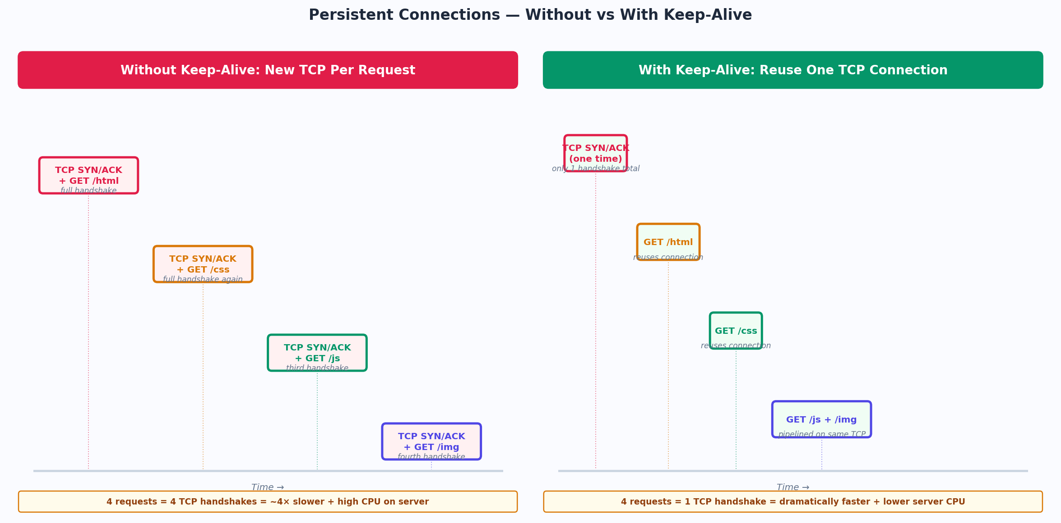
Figure 2 — Without keep-alive: 4 TCP handshakes. With keep-alive: 1 TCP handshake reused for all requests.

How the Headers Work
Header | Value | Meaning
Connection | keep-alive | Keep this TCP connection open for more requests. HTTP/1.1 default.
Connection | close | Close the TCP connection after this response. Forces a new handshake next time.
Keep-Alive | timeout=5, max=100 | Keep the connection alive for up to 5 seconds idle OR 100 requests, whichever comes first.
Connection | upgrade | The client wants to switch protocols on this connection (e.g., WebSocket upgrade).

HTTP/1.1 vs HTTP/2 Keep-Alive
In HTTP/1.1, keep-alive reuses the TCP connection but requests are still serial — one at a time, in order. If you want three API calls, they queue up on the same connection. Some clients work around this by opening multiple connections (browsers typically open 6 per domain).
HTTP/2 is a completely different model. A single TCP connection carries multiple streams simultaneously — each stream is an independent request/response. This is called multiplexing. There is no head-of-line blocking, no need for multiple connections, and no limit of 6. One connection, many parallel requests. Keep-Alive in HTTP/2 is handled at the framing layer, not via headers.

Full Express Implementation
Node's built-in HTTP server has default timeout values that may not match your production requirements. Express sits on top of Node's http.createServer, so you configure timeouts on the underlying server object. When you are behind a reverse proxy (Nginx, AWS ALB), the proxy has its own keep-alive settings that must be coordinated with Node's settings — mismatches cause 502 Bad Gateway errors.
install (http2 is built-in to Node.js)
npm install express spdy
# spdy adds HTTP/2 support over TLS to Express
# Node 18+ also has native http2 module (used below)

keepalive/app.js — full implementation
const express = require('express')
const http = require('http')
const https = require('https')
const fs = require('fs')
const app = express()

━━━━━━━━━━━━━━━━━━━━━━━━━━━━━━━━━━━━━━━━━━━━━━━━━━━━━━━━━━━━━━━━━
PART 1 — Configure keep-alive on the HTTP server
━━━━━━━━━━━━━━━━━━━━━━━━━━━━━━━━━━━━━━━━━━━━━━━━━━━━━━━━━━━━━━━━━

const server = http.createServer(app)

// keepAliveTimeout: how long to hold an idle connection open (ms)
// Node default is 5000ms. Nginx default is 75s.
// CRITICAL: Node keepAliveTimeout must be > proxy keepalive timeout
// or the proxy sends a request on a connection Node has already closed → 502
server.keepAliveTimeout = 65000 // 65s (more than Nginx's 60s default)

// headersTimeout: max time to receive the full request headers after connection
// Must be > keepAliveTimeout to prevent race conditions
server.headersTimeout = 66000 // always set slightly higher than keepAliveTimeout

// requestTimeout: total time allowed for the entire request lifecycle
server.requestTimeout = 300000 // 5 minutes (for large uploads)

server.listen(3000, () => {
console.log('HTTP/1.1 server listening on :3000')
console.log(`keepAliveTimeout: ${server.keepAliveTimeout}ms`)
})

━━━━━━━━━━━━━━━━━━━━━━━━━━━━━━━━━━━━━━━━━━━━━━━━━━━━━━━━━━━━━━━━━
PART 2 — Sending Connection header from your routes
━━━━━━━━━━━━━━━━━━━━━━━━━━━━━━━━━━━━━━━━━━━━━━━━━━━━━━━━━━━━━━━━━

// Keep-alive is default in HTTP/1.1. You only set Connection: close
// when you deliberately want to close after this response.
app.post('/api/close-after', (req, res) => {
res.set('Connection', 'close') // server closes TCP after this
res.json({ done: true })
})

// Normal route — keep-alive happens automatically, nothing to set
app.get('/api/data', async (req, res) => {
const data = await fetchData()
res.json(data)
// Connection stays open after this — next request reuses TCP
})

━━━━━━━━━━━━━━━━━━━━━━━━━━━━━━━━━━━━━━━━━━━━━━━━━━━━━━━━━━━━━━━━━
PART 3 — Making keep-alive HTTP requests FROM Node (as a client)
━━━━━━━━━━━━━━━━━━━━━━━━━━━━━━━━━━━━━━━━━━━━━━━━━━━━━━━━━━━━━━━━━

// By default Node's http/https does NOT reuse connections between requests
// You must explicitly pass an agent with keepAlive:true
const http = require('http')
const keepAliveAgent = new http.Agent({
keepAlive: true, // reuse connections between requests
maxSockets: 50, // max concurrent connections to one host
maxFreeSockets: 10, // max idle connections to keep in pool
timeout: 60000 // idle socket timeout before closing
})

// Use it in fetch calls or any http.request() call
const callInternalService = async () => {
const res = await fetch('http://internal-service/api', {
// In Node 18+ fetch, pass agent via dispatcher or use undici
// For node-fetch or axios, you pass the agent directly:
// agent: keepAliveAgent
})
return res.json()
}

━━━━━━━━━━━━━━━━━━━━━━━━━━━━━━━━━━━━━━━━━━━━━━━━━━━━━━━━━━━━━━━━━
PART 4 — HTTP/2 with native node:http2
━━━━━━━━━━━━━━━━━━━━━━━━━━━━━━━━━━━━━━━━━━━━━━━━━━━━━━━━━━━━━━━━━

const http2 = require('node:http2')

// HTTP/2 server (requires TLS in production — browsers enforce this)
const h2server = http2.createSecureServer({
key: fs.readFileSync('server.key')
cert: fs.readFileSync('server.cert')
})

h2server.on('stream', (stream, headers) => {
// :method, :path, :scheme, :authority are HTTP/2 pseudo-headers
const path = headers[':path']

if (path === '/api/data') {
stream.respond({
':status': 200,
'content-type': 'application/json',
// No Connection header needed — HTTP/2 manages this at framing layer
})
stream.end(JSON.stringify({ hello: 'http2' })
}
})

// HTTP/2 multiplexes automatically — no explicit keep-alive config needed
// Multiple streams share one TCP connection by design
h2server.listen(8443)

Note
The most common production bug with keep-alive: Node's keepAliveTimeout defaults to 5 seconds, but AWS ALB and Nginx have 60-75 second timeouts. If the proxy keeps the connection open and sends another request after Node has closed it, you get a 502. Always set Node's keepAliveTimeout to be slightly higher than your proxy's keepalive timeout.

verify keep-alive is working
# --http1.1 forces HTTP/1.1, -v shows headers
curl -v --http1.1 http://localhost:3000/api/data 2>&1 | grep -i connection

# In the response headers you should see:
< Connection: keep-alive
< Keep-Alive: timeout=65

# Run multiple requests and watch if new TCP connections are opened:
for i in {1..5}; do curl -s -o /dev/null -w '%{time_connect}\n' http://localhost:3000/api/data; done
# First request: ~5ms (TCP handshake)
# Subsequent requests: ~0.1ms (connection reused)

Interview Questions — Section 02

Interview Questions — What Gets Asked From This Section
What is the TCP handshake tax and how does keep-alive eliminate it? | Every new TCP connection requires 3 packets (SYN → SYN-ACK → ACK) before any HTTP data flows. On a 50ms RTT connection, that's ~75ms of pure overhead per request. Keep-alive reuses the open TCP socket, so subsequent requests skip the handshake entirely.
HTTP/1.1 keep-alive vs HTTP/2 multiplexing — what's the difference? | HTTP/1.1 keep-alive reuses TCP but requests are still serial — one at a time per connection. HTTP/2 multiplexes multiple streams on one TCP connection simultaneously. A browser can make 100 parallel requests over a single HTTP/2 connection with no queuing.
Why does keepAliveTimeout misconfiguration cause 502 errors? | If Node's keepAliveTimeout is lower than the proxy's, the proxy sends a request on a connection Node has already closed. Node rejects it with a RST packet, the proxy cannot forward the response, and returns 502 to the client. Fix: set Node's timeout > proxy's timeout.
What is head-of-line blocking in HTTP/1.1? | With HTTP/1.1 persistent connections, requests are processed in order. If request #1 is slow (database query), requests #2 and #3 wait in line even if the server could handle them. HTTP/2 eliminates this by using independent streams.
When would you explicitly send Connection: close? | When you want to signal the client that the session is definitively over — for example, after a logout response, after a one-time link is used, or when a server is shutting down and you want to drain connections gracefully without waiting for client-side timeouts.

03 | Multipart Data & Chunked Transfer  File uploads with multipart/form-data and streaming responses with Transfer-Encoding: chunked

Two Different Things — Often Confused
These two concepts are often grouped together in courses because they both involve data arriving or leaving in parts — but they solve fundamentally different problems and work in opposite directions.
 | Multipart/form-data | Chunked Transfer
Direction | Client → Server (upload) | Server → Client (streaming download)
Purpose | Send multiple distinct pieces in one request | Send a response without knowing total size upfront
Typical use | File uploads, form fields + file together | Live feeds, reports, DB cursor streaming
Key header | Content-Type: multipart/form-data; boundary=... | Transfer-Encoding: chunked (no Content-Length)
Express tool | multer middleware parses the parts | res.write() in a loop, then res.end()

Part A — Multipart/form-data (File Uploads)
When a user selects a file in a browser form, the browser cannot send it as application/json because JSON is text and binary files are not valid text. Instead, the browser uses multipart/form-data — a format that wraps each piece of data (text field, file, another field) in its own "part", separated by a boundary string. The boundary is a random string that doesn't appear in the data.
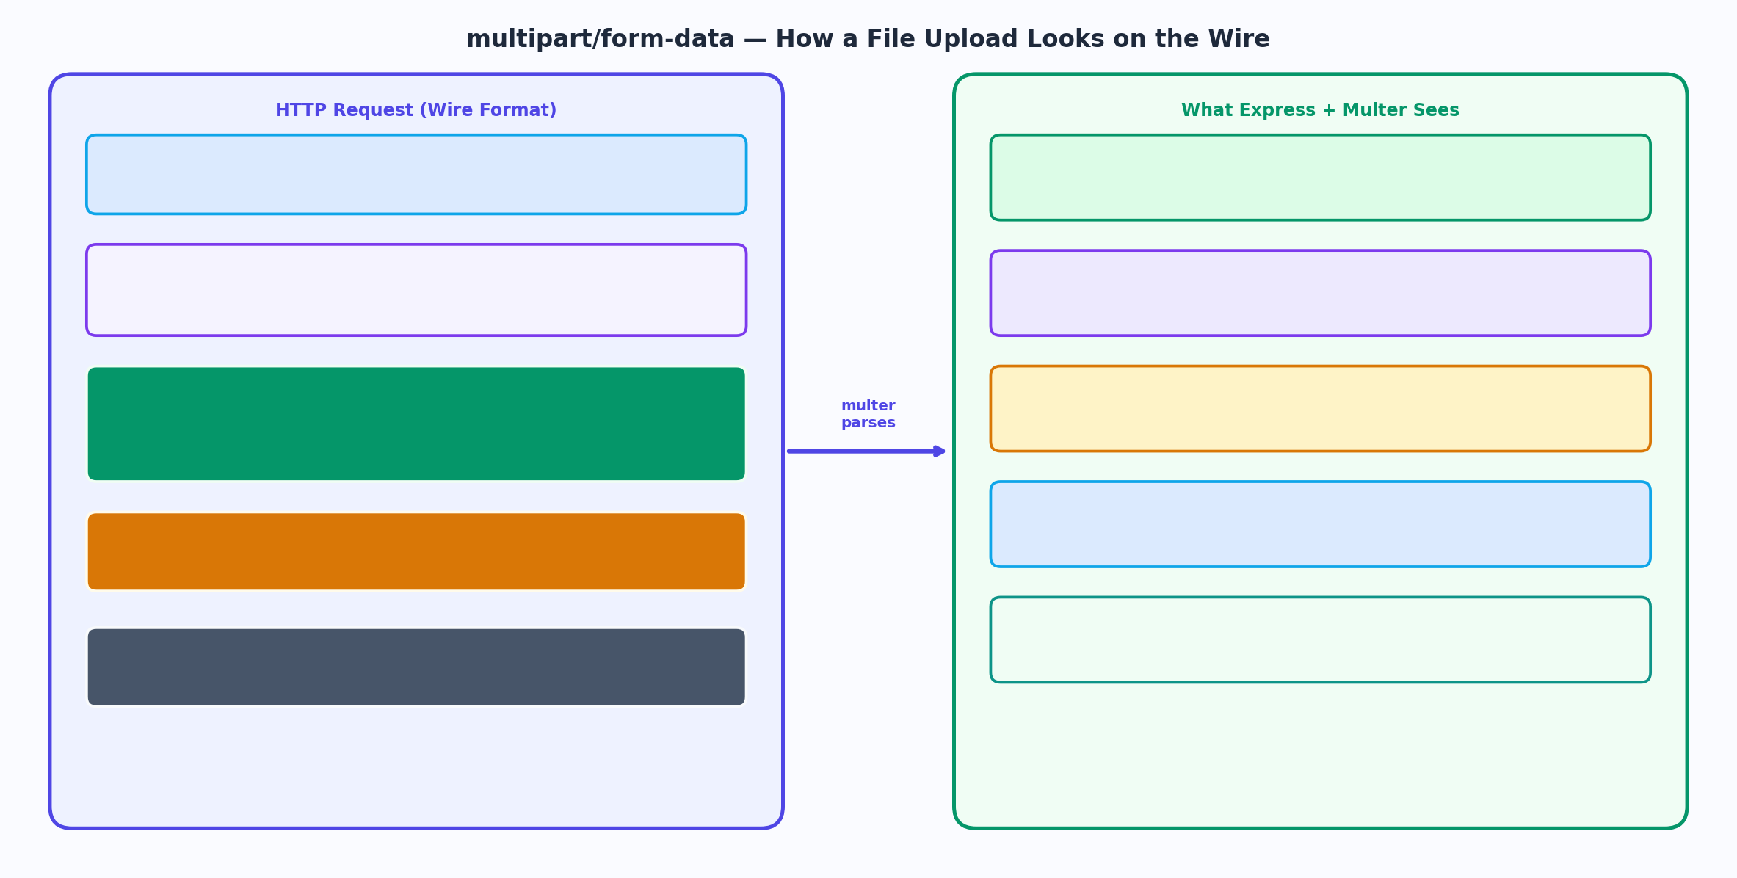
Figure 3 — How multipart/form-data looks on the wire, and what Express/Multer extracts from it

install multer
npm install multer

multipart/upload.js — full file upload implementation
const express = require('express')
const multer = require('multer')
const path = require('path')
const fs = require('fs')
const crypto = require('crypto')
const app = express()

━━━━━━━━━━━━━━━━━━━━━━━━━━━━━━━━━━━━━━━━━━━━━━━━━━━━━━━━━━━━━━━━━
STORAGE OPTION 1 — Memory storage (for small files, immediate processing)
━━━━━━━━━━━━━━━━━━━━━━━━━━━━━━━━━━━━━━━━━━━━━━━━━━━━━━━━━━━━━━━━━
const memoryStorage = multer.memoryStorage()
// File lives in req.file.buffer — good for: resizing images before S3 upload

━━━━━━━━━━━━━━━━━━━━━━━━━━━━━━━━━━━━━━━━━━━━━━━━━━━━━━━━━━━━━━━━━
STORAGE OPTION 2 — Disk storage (for large files or persistent storage)
━━━━━━━━━━━━━━━━━━━━━━━━━━━━━━━━━━━━━━━━━━━━━━━━━━━━━━━━━━━━━━━━━
const diskStorage = multer.diskStorage({
// destination: where to store the file on disk
destination: (req, file, cb) => {
const dir = path.join(__dirname, 'uploads')
fs.mkdirSync(dir, { recursive: true })
cb(null, dir)
},
// filename: rename the file to avoid collisions
filename: (req, file, cb) => {
const ext = path.extname(file.originalname)
const uniqueName = `${crypto.randomUUID()}${ext}`
cb(null, uniqueName)
}
})

━━━━━━━━━━━━━━━━━━━━━━━━━━━━━━━━━━━━━━━━━━━━━━━━━━━━━━━━━━━━━━━━━
MULTER INSTANCE — with file type and size validation
━━━━━━━━━━━━━━━━━━━━━━━━━━━━━━━━━━━━━━━━━━━━━━━━━━━━━━━━━━━━━━━━━
const ALLOWED_MIME_TYPES = ['image/jpeg', 'image/png', 'image/webp', 'application/pdf']
const upload = multer({
storage: diskStorage,
limits: {
fileSize: 5 * 1024 * 1024, // 5MB per file
files: 5 // max 5 files per request
},
// fileFilter: validate MIME type BEFORE the file is saved to disk
fileFilter: (req, file, cb) => {
if (!ALLOWED_MIME_TYPES.includes(file.mimetype) {
return cb(new Error(`File type ${file.mimetype} not allowed`), false)
}
cb(null, true) // accept the file
}
})

━━━━━━━━━━━━━━━━━━━━━━━━━━━━━━━━━━━━━━━━━━━━━━━━━━━━━━━━━━━━━━━━━
ROUTE 1 — Single file upload (avatar, document)
━━━━━━━━━━━━━━━━━━━━━━━━━━━━━━━━━━━━━━━━━━━━━━━━━━━━━━━━━━━━━━━━━
app.post('/api/upload/avatar',
upload.single('avatar'), // "avatar" must match the form field name
(req, res) => {
if (!req.file) {
return res.status(400).json({ error: 'No file uploaded' })
}
// req.file contains all file metadata:
// { fieldname, originalname, encoding, mimetype, filename, path, size }
res.status(201).json({
message: 'Upload successful',
file: {
name: req.file.filename,
size: req.file.size,
type: req.file.mimetype,
url: `/uploads/${req.file.filename}`
}
})
})

━━━━━━━━━━━━━━━━━━━━━━━━━━━━━━━━━━━━━━━━━━━━━━━━━━━━━━━━━━━━━━━━━
ROUTE 2 — Mixed: form fields + multiple files in one request
━━━━━━━━━━━━━━━━━━━━━━━━━━━━━━━━━━━━━━━━━━━━━━━━━━━━━━━━━━━━━━━━━
app.post('/api/upload/profile',
upload.fields([ // named fields — matches HTML form
{ name: 'avatar', maxCount: 1 },
{ name: 'documents', maxCount: 5 }
]),
async (req, res) => {
// req.files is an object keyed by field name:
// { avatar: [FileObject], documents: [FileObject, FileObject, ...] }
const avatar = req.files['avatar']?.[0]
const documents = req.files['documents'] || []
const { name, bio } = req.body // text fields in req.body

const profile = await User.updateProfile({
name, bio,
avatarUrl: avatar ? `/uploads/${avatar.filename` : undefined,
documentUrls: documents.map(d => `/uploads/${d.filename`)
})
res.json(profile)
})

━━━━━━━━━━━━━━━━━━━━━━━━━━━━━━━━━━━━━━━━━━━━━━━━━━━━━━━━━━━━━━━━━
Multer error handling — must be caught explicitly
━━━━━━━━━━━━━━━━━━━━━━━━━━━━━━━━━━━━━━━━━━━━━━━━━━━━━━━━━━━━━━━━━
app.use((err, req, res, next) => {
if (err.code === 'LIMIT_FILE_SIZE') {
return res.status(413).json({ error: 'File too large. Max 5MB.' })
}
if (err.code === 'LIMIT_FILE_COUNT') {
return res.status(400).json({ error: 'Too many files' })
}
if (err.message?.includes('not allowed') {
return res.status(415).json({ error: err.message })
}
next(err)
})

app.listen(3000)

Watch out
Never trust the MIME type the client sends in the multipart header. A malicious client can send Content-Type: image/jpeg for a file that is actually a PHP script or executable. Validate the actual file signature (magic bytes) server-side, not just the MIME type. Libraries like file-type can read the first few bytes of the buffer to determine the real format.

Part B — Chunked Transfer Encoding (Streaming Responses)
When your server doesn't know the total size of a response before it starts sending — a database cursor streaming rows, a real-time event feed, a large file being generated on the fly — it cannot set a Content-Length header. Chunked transfer encoding solves this by letting the server send the response body in pieces, each piece prefixed with its size in hexadecimal. The client knows the stream is complete when it receives a chunk of size 0.
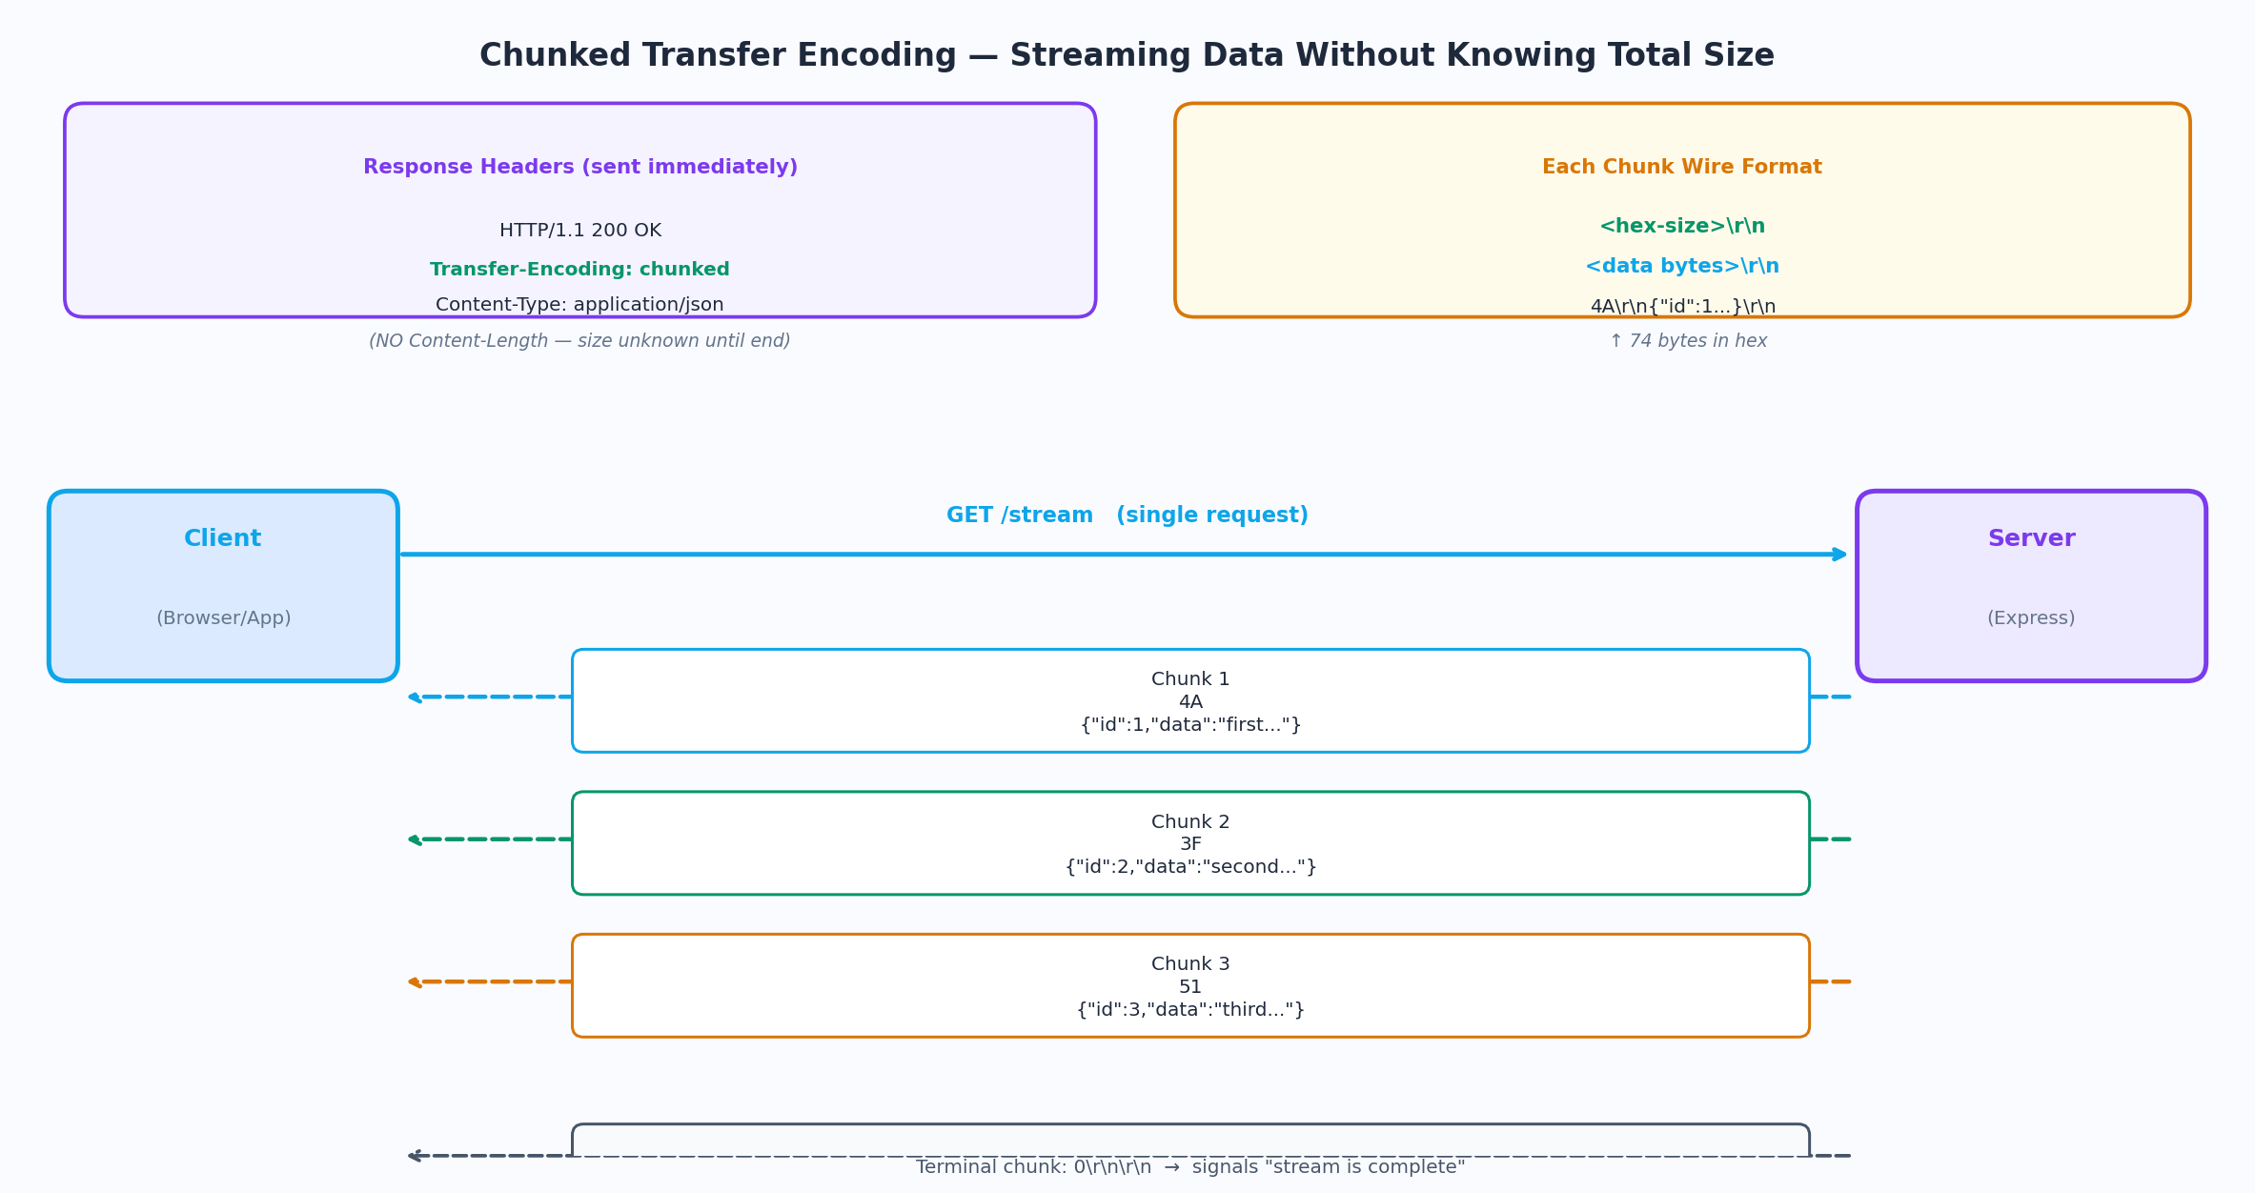
Figure 4 — Chunked transfer wire format: each chunk has a hex size prefix, stream ends with 0-byte chunk

chunked/stream.js — full streaming implementation
const express = require('express')
const fs = require('fs')
const path = require('path')
const app = express()

━━━━━━━━━━━━━━━━━━━━━━━━━━━━━━━━━━━━━━━━━━━━━━━━━━━━━━━━━━━━━━━━━
EXAMPLE 1 — Stream a large file from disk
Node pipe() handles chunking automatically — no manual chunks needed
━━━━━━━━━━━━━━━━━━━━━━━━━━━━━━━━━━━━━━━━━━━━━━━━━━━━━━━━━━━━━━━━━
app.get('/stream/file', (req, res) => {
const filePath = path.join(__dirname, 'data/large-dataset.json')
const stat = fs.statSync(filePath)

// When Content-Length is set, response is NOT chunked
// When it is omitted, Node automatically uses Transfer-Encoding: chunked
res.set({
'Content-Type': 'application/json',
// Deliberately NOT setting Content-Length → triggers chunked encoding
'X-Total-Size': stat.size // informational only, not Content-Length
})

const readStream = fs.createReadStream(filePath, { highWaterMark: 64 * 1024 })
// highWaterMark: chunk size in bytes (64KB here)
// pipe() handles: backpressure, errors, and calling res.end() when done
readStream.pipe(res)

// Error handling: if file read fails, abort the stream
readStream.on('error', (err) => {
console.error('Stream error:', err)
if (!res.headersSent) {
res.status(500).json({ error: 'Stream failed' })
} else {
res.destroy()
}
})
})

━━━━━━━━━━━━━━━━━━━━━━━━━━━━━━━━━━━━━━━━━━━━━━━━━━━━━━━━━━━━━━━━━
EXAMPLE 2 — Manual chunked streaming (JSON objects, one per chunk)
Use case: stream DB rows as they arrive without loading all into memory
━━━━━━━━━━━━━━━━━━━━━━━━━━━━━━━━━━━━━━━━━━━━━━━━━━━━━━━━━━━━━━━━━
app.get('/stream/rows', async (req, res) => {
// Set headers BEFORE writing any body chunks
res.set({
'Content-Type': 'application/x-ndjson', // newline-delimited JSON
'Transfer-Encoding': 'chunked' // explicit, though Node sets this automatically
'X-Accel-Buffering': 'no' // tell Nginx to NOT buffer this response
'Cache-Control': 'no-cache'
})

// Simulate a DB cursor — in real code this is a database stream
const dbCursor = simulateDbCursor()

for await (const row of dbCursor) {
// res.write() sends one chunk immediately without buffering
// NDJSON: one JSON object per line, client parses line by line
const ok = res.write(JSON.stringify(row) + '\n')
if (!ok) { // backpressure: client is slow
// Wait for drain event before sending more data
await new Promise(resolve => res.once('drain', resolve))
}
}

// res.end() sends the terminal 0-byte chunk — signals stream complete
res.end()
})

━━━━━━━━━━━━━━━━━━━━━━━━━━━━━━━━━━━━━━━━━━━━━━━━━━━━━━━━━━━━━━━━━
EXAMPLE 3 — Server-Sent Events (SSE): real-time push over chunked HTTP
SSE is chunked transfer with a specific text/event-stream content type
━━━━━━━━━━━━━━━━━━━━━━━━━━━━━━━━━━━━━━━━━━━━━━━━━━━━━━━━━━━━━━━━━
app.get('/stream/events', (req, res) => {
// SSE protocol: keep connection open, push "data: ...
" events
res.set({
'Content-Type': 'text/event-stream',
'Cache-Control': 'no-cache',
'Connection': 'keep-alive',
'X-Accel-Buffering': 'no' // critical: disable Nginx buffering
})

// SSE comment: acts as a heartbeat, keeps connection alive through proxies
res.write(': keep-alive\n\n')

const intervalId = setInterval(() => {
const event = { time: new Date().toISOString(), value: Math.random() }
// SSE format: "data: <json>\n\n" (double newline ends each event)
res.write(`data: ${JSON.stringify(event)}\n\n`)
}, 1000)

// Clean up the interval when client disconnects
req.on('close', () => {
clearInterval(intervalId)
console.log('SSE client disconnected')
})
})

━━━━━━━━━━━━━━━━━━━━━━━━━━━━━━━━━━━━━━━━━━━━━━━━━━━━━━━━━━━━━━━━━
Helper: simulate a database cursor (async generator)
━━━━━━━━━━━━━━━━━━━━━━━━━━━━━━━━━━━━━━━━━━━━━━━━━━━━━━━━━━━━━━━━━
async function* simulateDbCursor() {
for (let i = 0; i < 1000; i++) {
// Simulate async DB fetch delay
await new Promise(r => setTimeout(r, 5))
yield { id: i, data: `row-${i}`, ts: Date.now() }
}
}

app.listen(3000)

Note
X-Accel-Buffering: no is critical when you are behind Nginx. By default, Nginx buffers the entire response before forwarding to the client — which defeats the entire purpose of streaming. This header tells Nginx to pass each chunk through immediately as it arrives from Node.

Interview Questions — Section 03

Interview Questions — What Gets Asked From This Section
What is the boundary in multipart/form-data and why does it exist? | The boundary is a unique string (chosen by the client, usually random) that separates the individual parts in a multipart request body. Without it, the server cannot tell where one file ends and the next begins, because file data is raw bytes with no inherent delimiter.
Why can't you upload a file as application/json? | JSON is a text format — all values must be valid UTF-8 strings. Binary file data (arbitrary bytes) is not valid UTF-8. Forcing binary through JSON requires Base64 encoding, which bloats the payload by ~33%. multipart/form-data carries raw binary bytes without any encoding overhead.
What is NDJSON and why is it used with chunked streaming? | Newline-Delimited JSON — one complete JSON object per line, with a newline separating objects. Suitable for streaming because the client can parse each line as it arrives without waiting for the full response. A standard JSON array cannot be streamed because the parser needs the closing ] to know the array is complete.
What is backpressure in Node.js streaming? | res.write() returns false when the internal write buffer is full — the client is receiving slower than the server is producing. You must pause sending and wait for the drain event before writing more, or you accumulate unbounded data in memory. Ignoring backpressure is a common Node.js memory leak.
How does SSE differ from WebSockets? | SSE is unidirectional (server to client only), works over plain HTTP/1.1, reconnects automatically if the connection drops, and uses a simple text format. WebSockets are bidirectional, require a protocol upgrade handshake, and carry arbitrary binary frames. SSE is better for dashboards and live feeds; WebSockets are better for chat and real-time gaming.
Why is the Content-Length header absent in chunked responses? | Content-Length requires knowing the full response size before sending any bytes. Chunked transfer encoding exists precisely for cases where the size is unknown upfront (streaming from a DB cursor, generating content dynamically). The two mechanisms are mutually exclusive — you cannot have both.

Packages used: compression · multer · node:zlib (built-in) · node:http2 (built-in) | Express 4.x / Node.js 18+

